Identifying Bone Tumor using X-Ray Images
In this project we are implementing deep learning Convolution Neural Network (CNN) to predict bone tumor and to train this algorithm we have used bone images with and without tumor.
To implement this project we have designed following modules
- Dataset upload: using this module we will upload dataset to application
- Dataset Preprocessing: using this module we will read all images and then convert them into GREY format and then resize all images to equal size and then normalize pixel values.
- Features Extraction: features or pixel values will be extracted from processed images and then input this features to CNN to trained tumor prediction model
- Segmentation & Classification: using this module we will read test image and then apply segmentation to extract tumor part and then predict weather image is normal or contains any tumor. Edge detection technique will be applied to surround bounding box across tumor part
To implement this project we have used below dataset
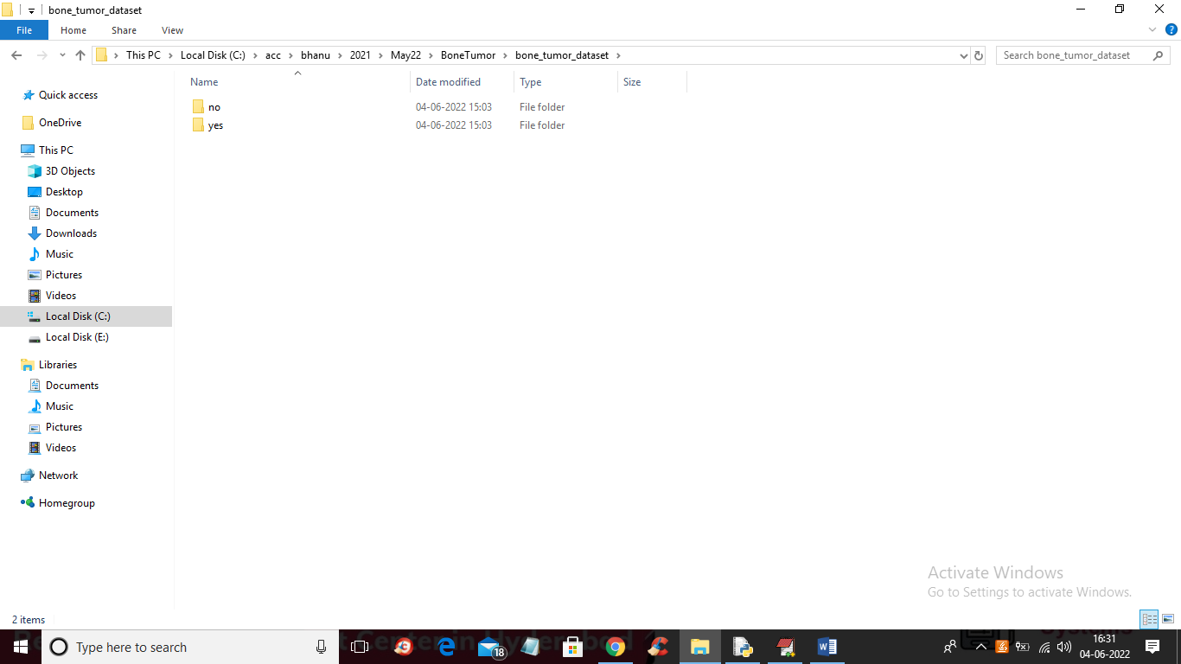
In above screen we have 2 folders called ‘no and yes’ where no folder contains normal bone images and ‘yes’ folder contains bone tumor images and just go inside any folder to view images like below screen
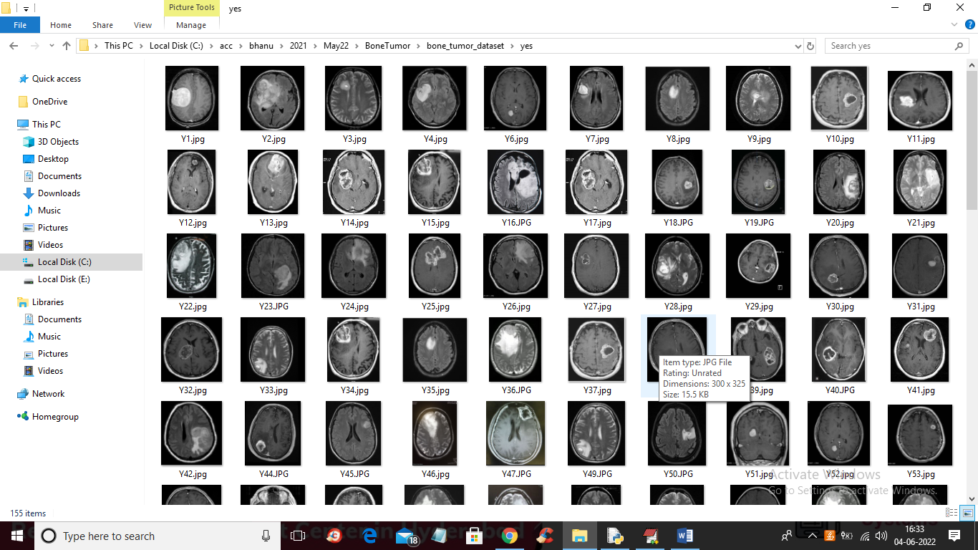
We are using above images to train CNN for tumor detection
SCREEN SHOTS
To run project double click on run.bat file to get below screen
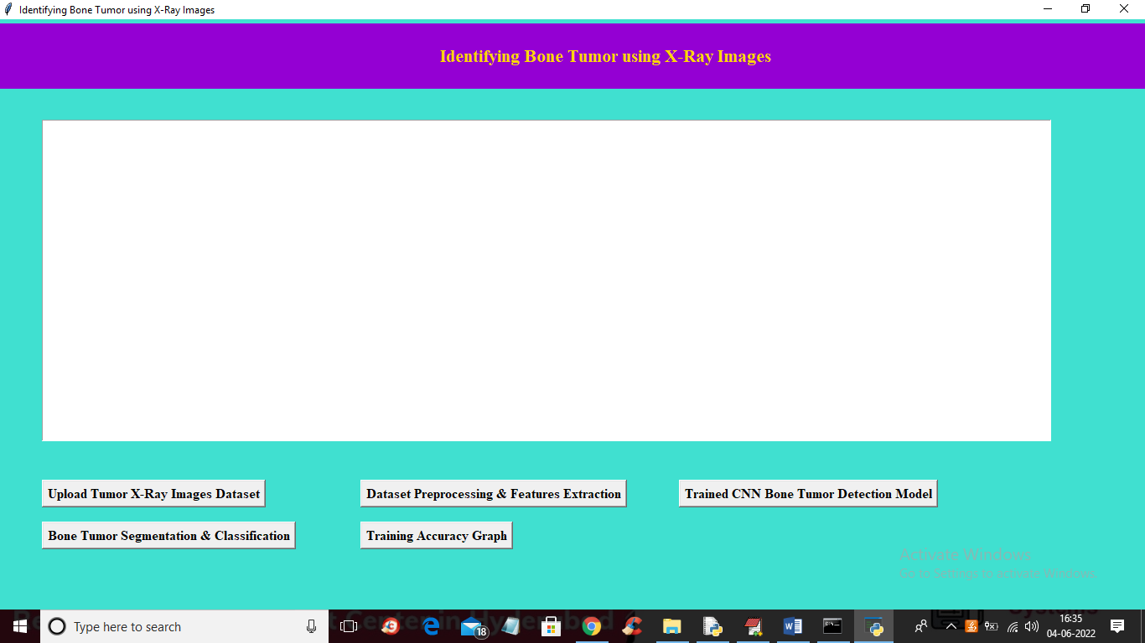
In above screen click on ‘Upload Tumor X-Ray Images Dataset’ button to upload X-Ray images dataset and get below output
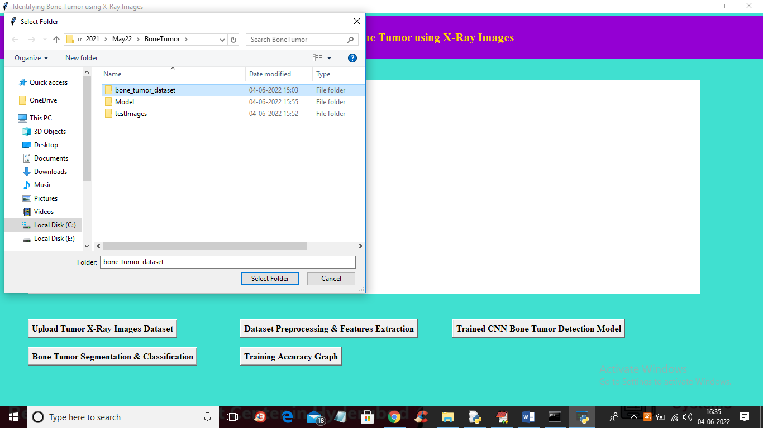
In above screen selecting and uploading brain tumor dataset and then click on ‘Select Folder’ button to load dataset and then get below output
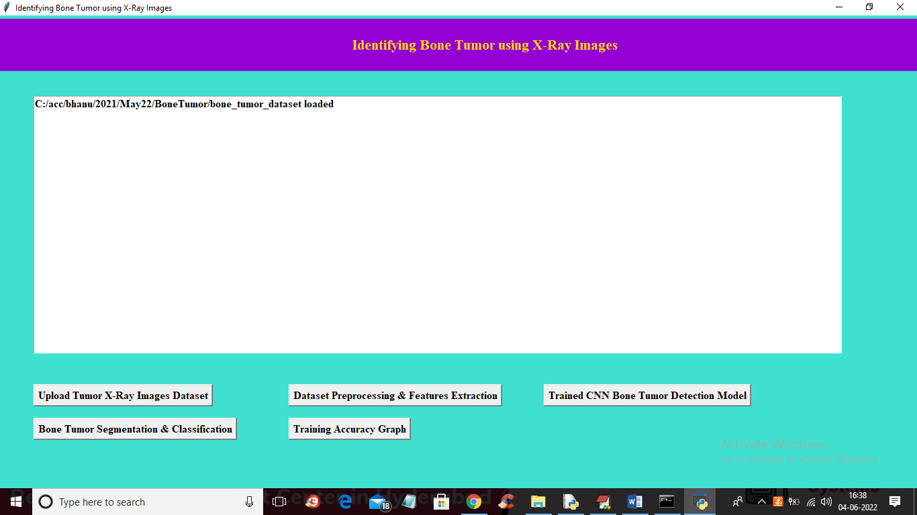
In above screen dataset loaded and now click on ‘Dataset Preprocessing & Features Extraction’ button to read all images and then process and extract features to train with CNN
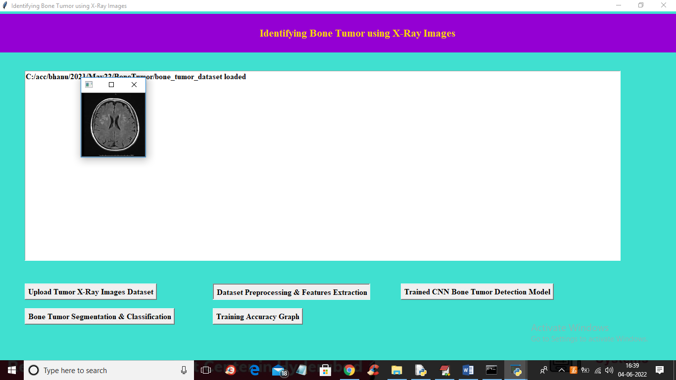
In above screen all images are processed and to check images are loaded properly so I am displaying one sample processed image and now close that image to get below output
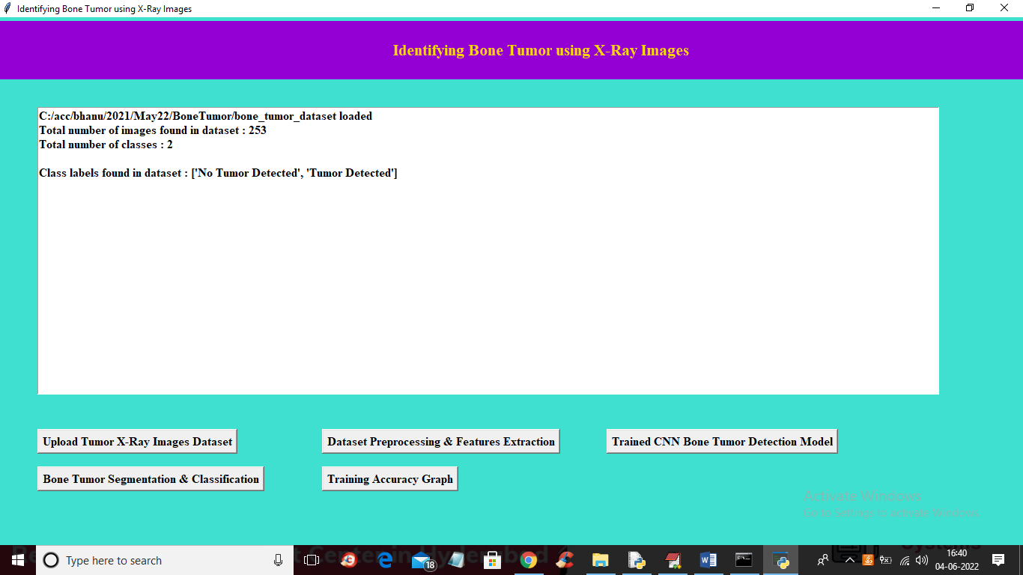
In above screen we can see dataset contains 253 images with and without tumor class label and now click on ‘Trained CNN Bone Tumor Detection Model’ button to train CNN with above extracted features and get below output
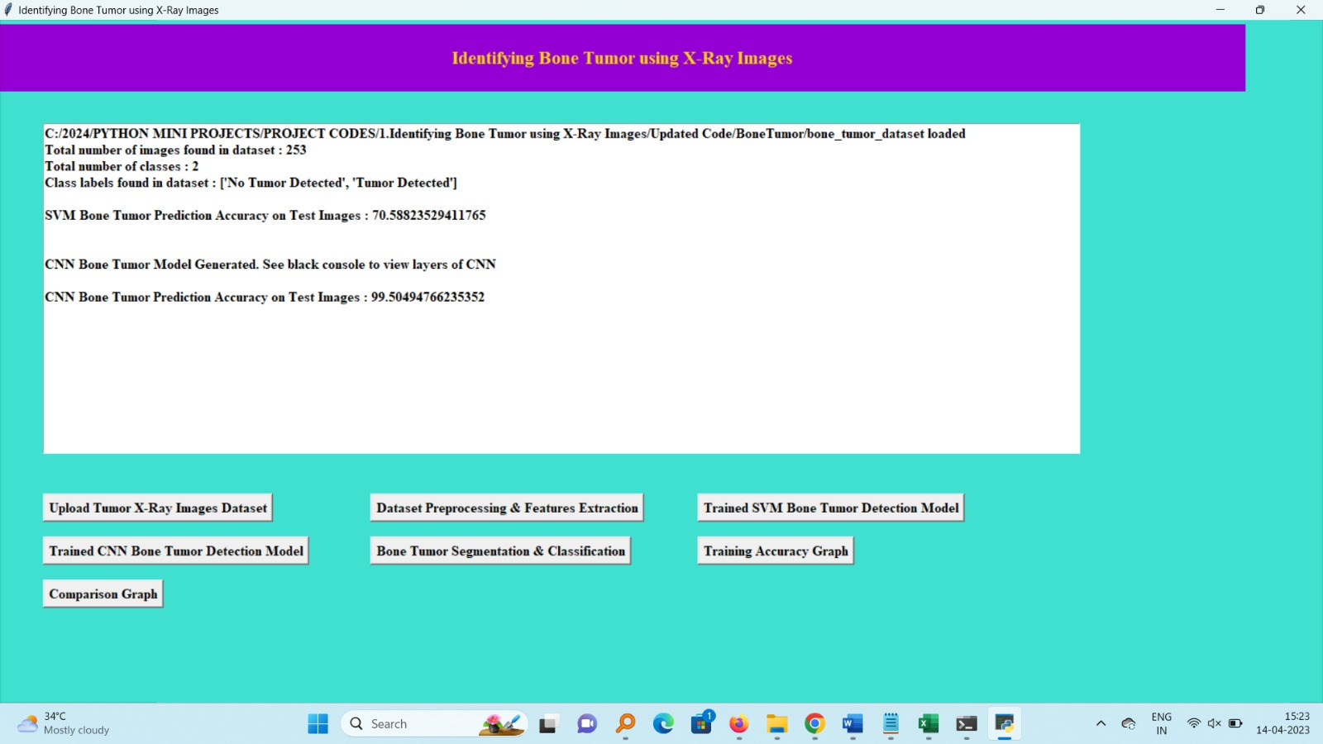
In above screen CNN training completed and we got it accuracy as 99.5% and now click on ‘Bone Tumor Segmentation & Classification’ button to upload test image and get below output
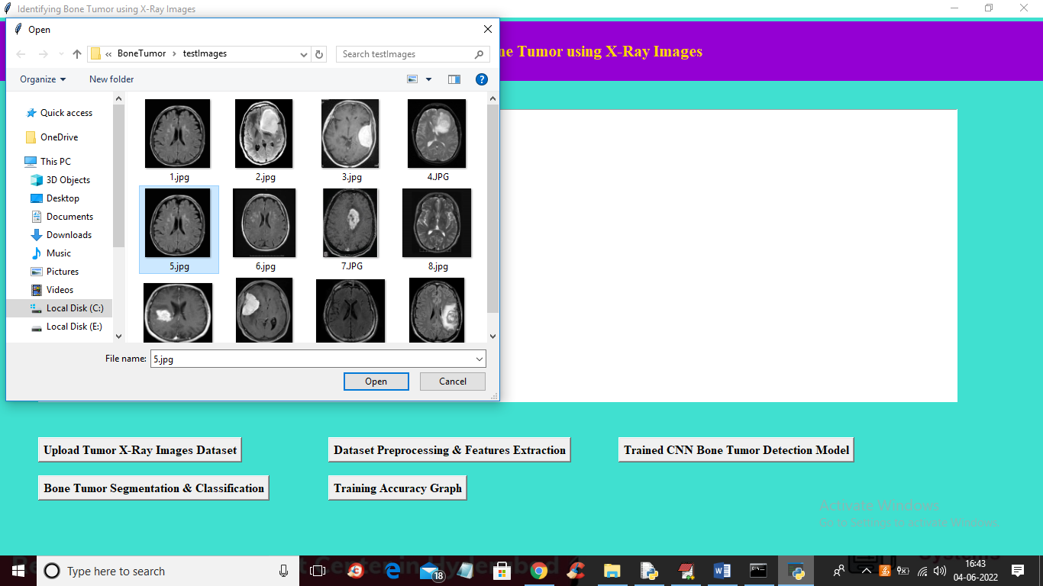
In above screen selecting and uploading 5.jpg file and then click on ‘Open’ button to get below output
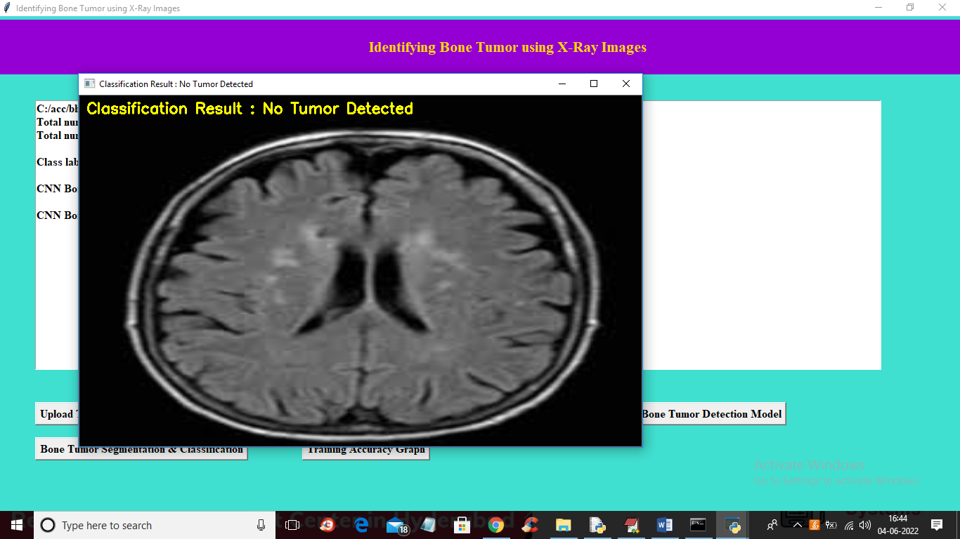
In above image ‘No Tumor Detected’ and now try another image
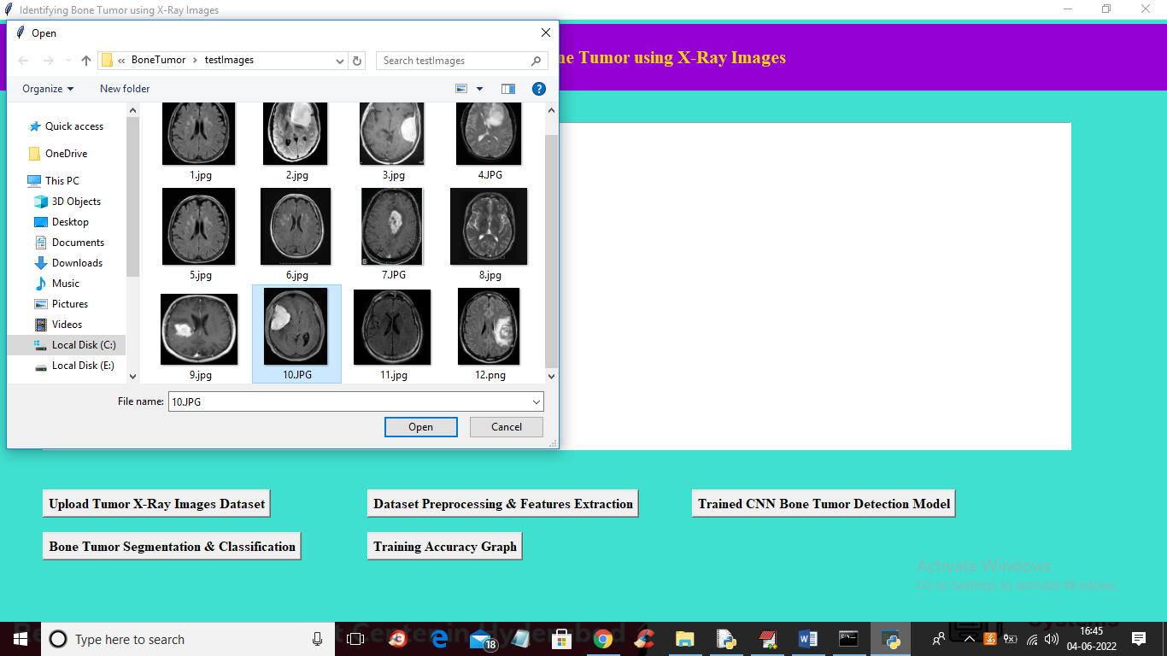
In above screen selecting and uploading ’10.jpg’ and then click on ‘Open’ button to get below output
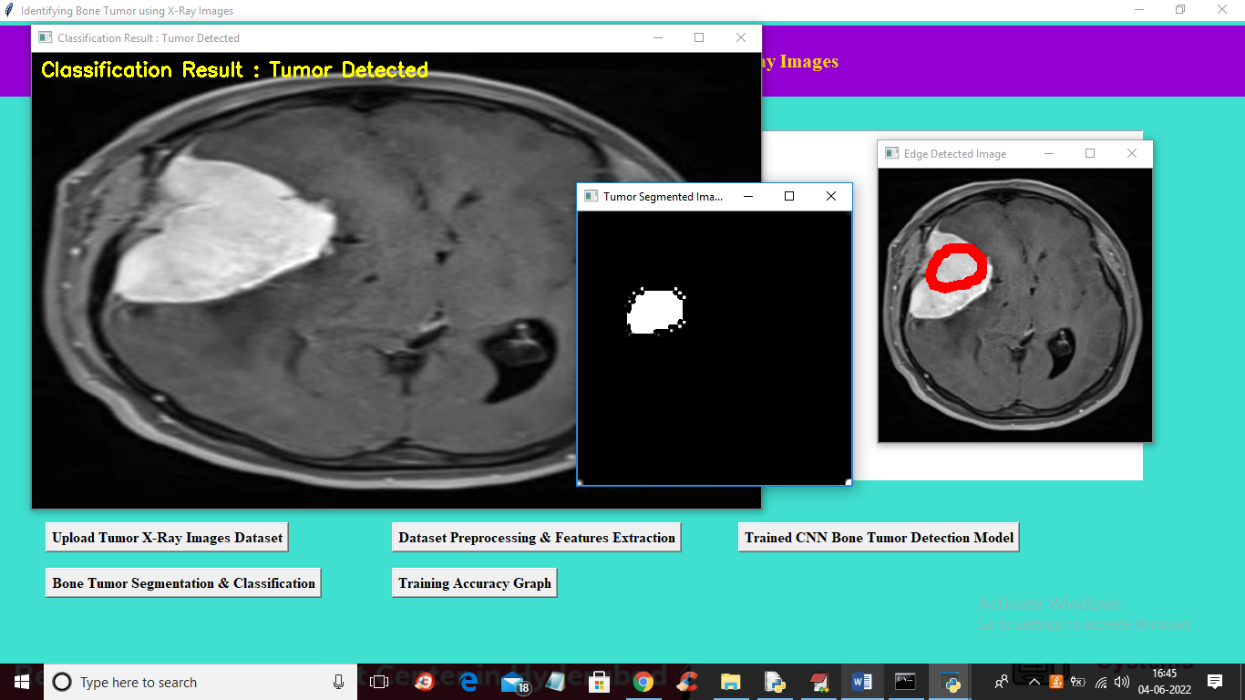
In above screen first image is the original image which classified as tumor detected and second image is tumor segmented image and 3rd image is the tumor edge detected image and see another image is below screen
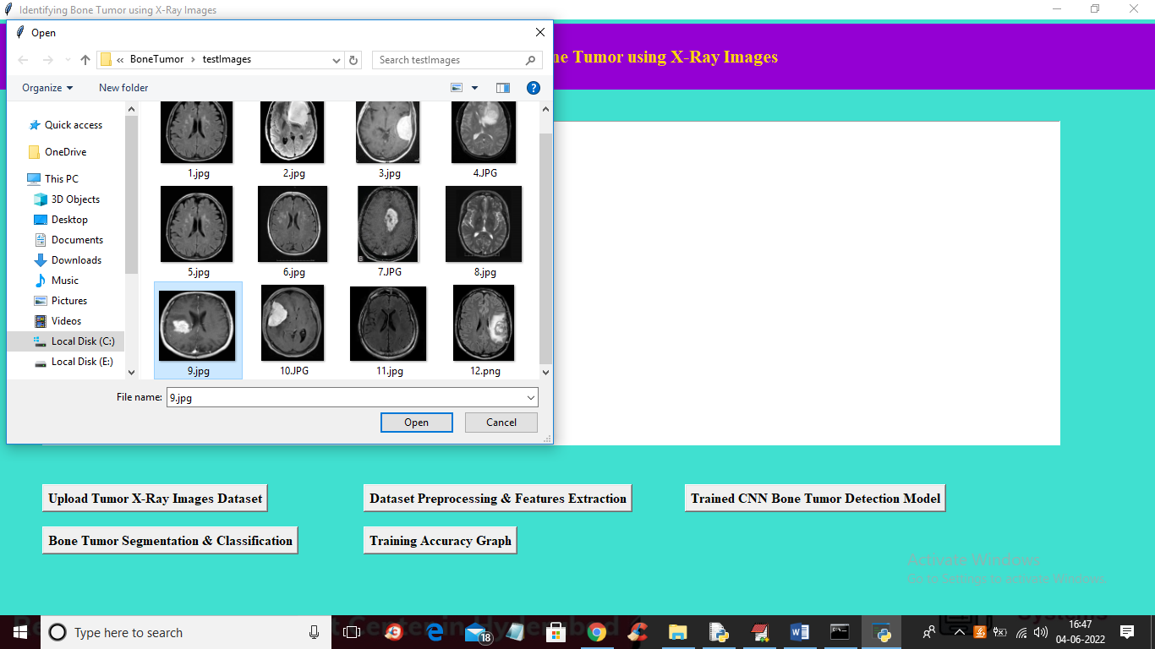
In above screen uploading 9.jpg image and click open button to get below output
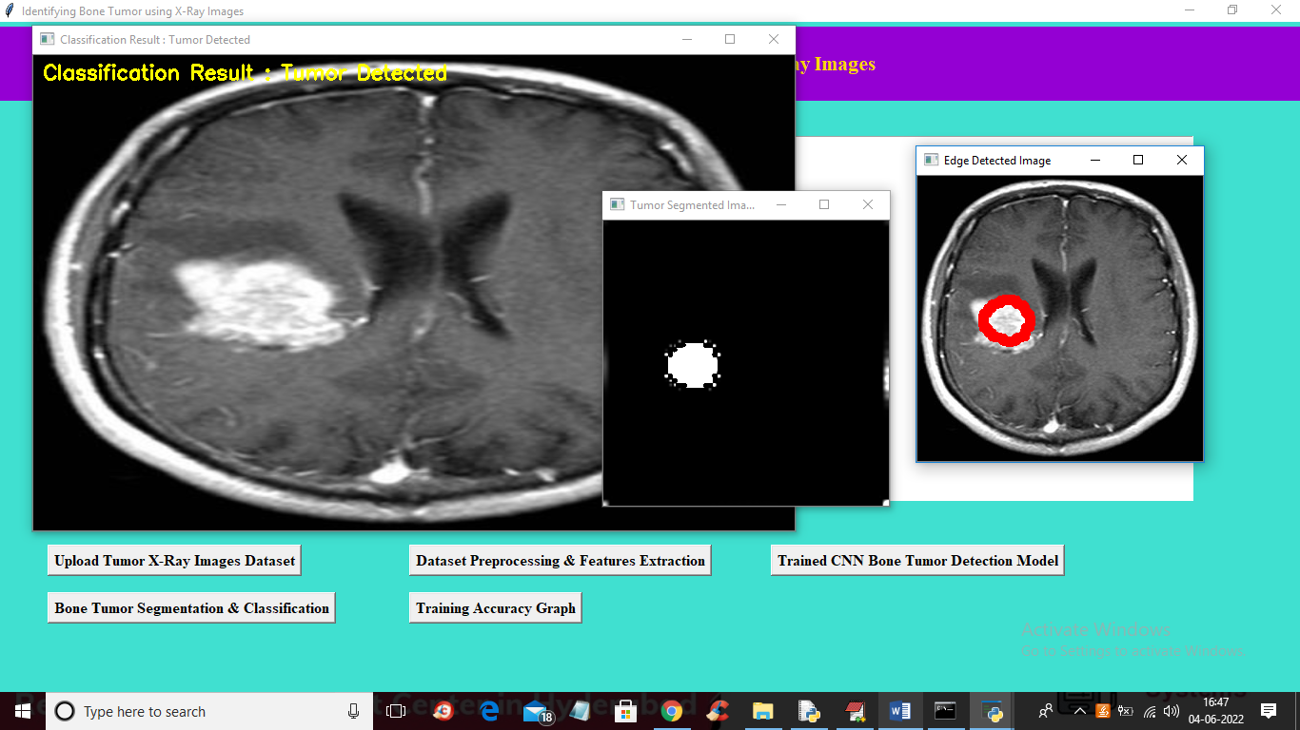
In above screen we can see tumor detected with segmented out tumor image and with tumor edge detected. Similarly you can upload other images and test and now click on ‘Training Accuracy Graph’ button to get below graph
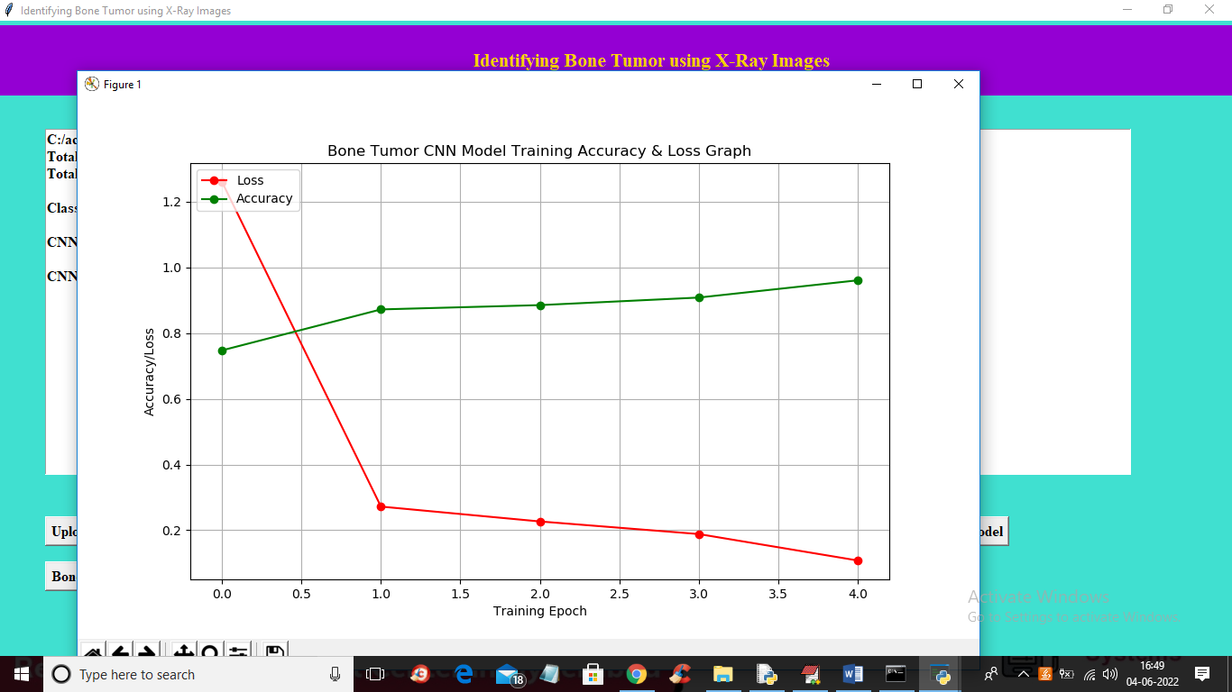
In above graph x-axis represents training EPOCH and y-axis represents training accuracy and loss values and green line representing accuracy and red line represents LOSS and in above graph we can see with each increasing epoch accuracy got increase and loss got decrease

